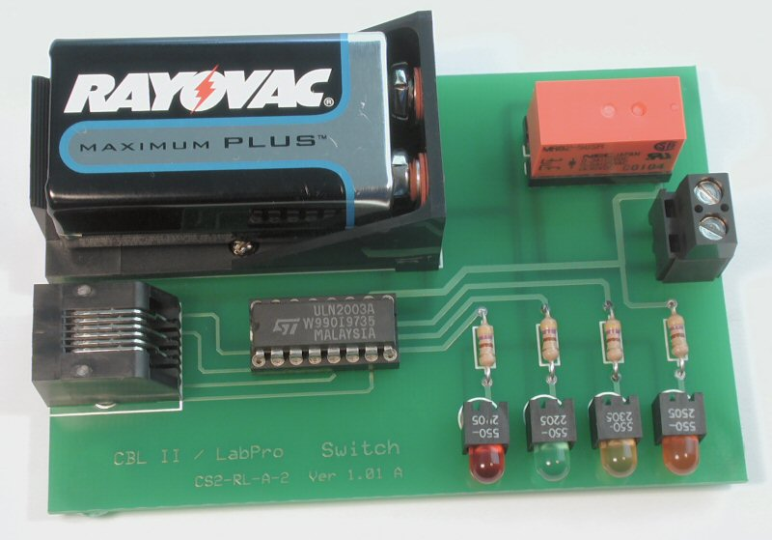
Building a Basic Switch
The Basic Switch provides 4 lights (LEDs) which will show the "high" or "low" voltage states for each of 4 output lines of a CBL2 or LabPro. One of those lines is also connected to a relay, which can act as an on-off switch for low-voltage, low current circuits. Although designed for use with TI graphing calculators and the CBL2 or LabPro interface, the board can be adapted for use with any interface which provides 4 5-volt output lines and a reference ground.
This project and instructions are intended for learners of any age who are unfamiliar with electronics and with soldering. Younger learners must have appropriate supervision.
The circuit should only be used to control low-current, DC circuits. It should never be used with AC or other potentially high-energy sources
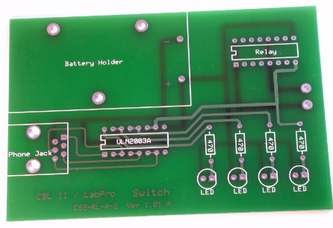
Step 1 -- Orientation to Printed Circuit Board
Look at the printed circuit board (PCB) and be sure you understand how it should be oriented. All of the components (except for 4 rubber feet) will be placed on top of the board while it is oriented as shown at left. You will then turn the board over and solder from the bottom.
Notice that the board is "double sided," meaning that it has lines of metal printed on both top and bottom. These metal traces are the "wires" which will conduct electricity. Look closely at some of the holes on the board. They are "plated through" so that metal goes through the board at those points. The board is also coated with a protective covering, so that metal is only exposed in and around the holes. Some of the largest holes have no metal traces, since they will be used for mechanical connections, not electrical connections.
Step 2 -- Identify the Components
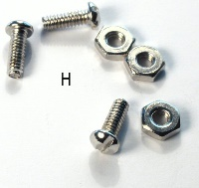
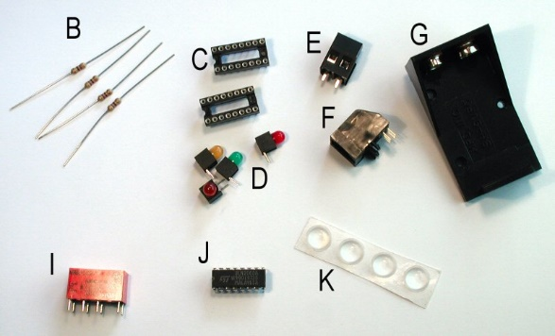
The parts to be attached to the PCB are shown at right. Identify each, and lay them out where you can keep track of them. The letters indicate the recommended order of assembly.
A | Printed Circuit Board | 1
B | Resistors, 470 ohm, 1/4 W | 4
C | Sockets, 16 pin DIP | 2
D | LEDs, right angle, different colors | 4
E | Terminal Block, 2 position | 1
F | Phone jack, 6P6C | 1
G | Battery cradle | 1
H | 2-56 machine screws and nuts | 3
I | Relay, DPDT, 5V | 1
J | Integrated circuit, ULN 2003A | 1
K | Rubber feet

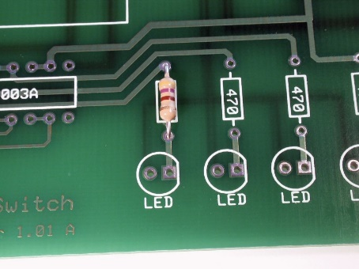
Step 3 -- Add the First Resistors
- Be sure that you and all the people near you are wearing eye protection.
- Be very alert to the fact that the soldering iron is hot.
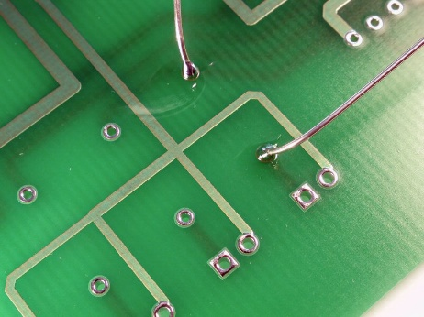
Insert one of the 470-ohm resistors from the top of the PCB. It works equally well no matter which way you insert it, but good practice requires that you orient the resistor so it's color code can be read from the top down. The resistor has colored bands of yellow, violet, and brown (for 47 x 10¹) and a gold band to indicate 5% tolerance. Yellow should be at the top.
Turn the board over and solder the 2 leads. When finished, you should see a small "candy kiss"-shaped mound of solder that clings to both the solder pad on the PCB and to the resistor's wire lead. You should also be able to see that the solder has passed through the hole in the PCB board.
Before continuing, cut off the excess wire--being very careful to protect your eyes and the eyes of everyone around you.
Step 4 -- Three More Resistors and 2 Sockets
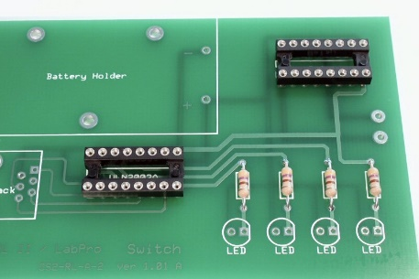
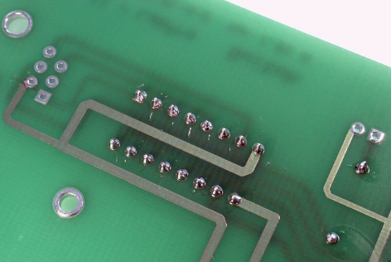
Solder the other 3 resistors into place in the same way as the first one.
Also place the 2 sockets onto the board. Before you solder them, be sure that the notch on each socket is pointed towards the left. As with the resistors, the socket will work in either orientation, but good practice demands that it be oriented so anyone placing or replacing a component in the socket will know how it goes.
Step 5 -- Put in the LEDs
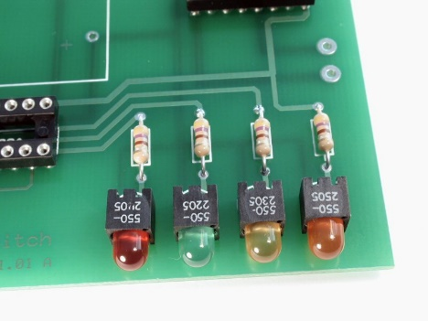
Think for a minute about how you want to arrange the LEDs. It's nice to maintain a single, systematic color code, but that's often not practical. The sequence shown at left of red-green-yellow-orange matches SOME of the colors of the wires from the CBL2 and LabPro. Blue and white LEDs to match those wires are more expensive than red and orange ones. For economic reasons, in our system only the green and yellow LEDs match the color of their wires. As shown, the LEDs are mounted with right-angle adapters. This is important if you intend to use the board for demonstrations where most viewers will be looking from the side.
Bottom line--feel free to develop your own logic for the sequence of colors or simply arrange the LEDs in the way you think looks best. It is essential to remember that LEDs—like all other diodes—only carry current in one direction. The flat side of the LED MUST match the flat side shown on the circuit board.
It is helpful to use masking tape to hold the LEDs straight while you solder them. It you don't, you could be stuck forever with a set of LEDs that are obviously out of line.

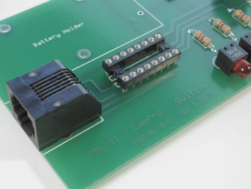
Step 6 -- Add the Phone Jack
The wire from the CBL2 or LabPro uses a 6-conductor phone wire, so we can use a phone jack to make our connection with the board. (Most house phone jacks in the US have 6 positions, but only 4 conductors (6P4C). Be careful if you try to substitute parts purchased locally that you are using 6P6C components.)
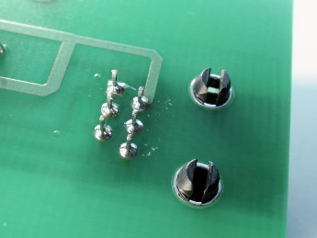
Very carefully start the 6 terminal wires in the 6 holes in the PCB, then snap the plastic holders into place. The terminals are smaller and closer together than the ones you've soldered up until this point, so they require less heat and more care. Be especially careful to avoid "solder bridges"--links of solder that accidentally connect one terminal to another. If you have a solder bridge, it needs to be removed using desoldering braid or another desoldering tool.

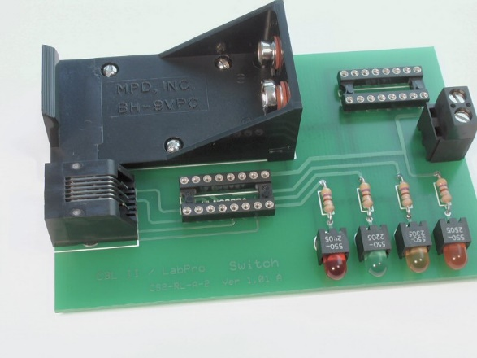
Step 7 -- Connect the Battery Cradle and the Terminal
The electrical signals coming from the CBL2 or LabPro contain a great deal of information but they have only a very small amount of energy. The calculator can provide the "brains" to operate the circuit, but it needs more "muscle" to operate the lights and the electromagnetic relay. A standard 9-Volt battery will provide that extra energy.
Insert the wires of the battery cradle through the PCB, and use the three sets of machine screws and nuts to fasten the cradle into place. After you attach the screws, solder the wires which make the electrical connections from the battery terminals to the PCB.
Also solder the 2-position terminal jack into position as shown. Note that the terminal jack connectors are larger than the other wires, and will require both more heat and more solder.
Step 8 -- Insert the IC and the Relay
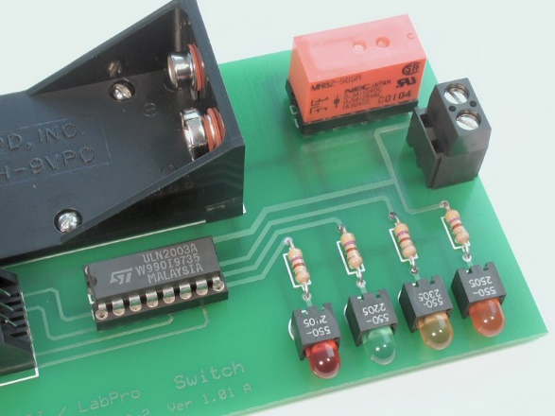
The integrated circuit (IC) and the relay will slip into the sockets without any more soldering, but your need to be very careful that (1) you don't bend any of the terminals, and (2) you have each component oriented correctly.
The IC has either a notch or a dot at one end which should be aligned with the notch in its socket. (Remember how careful you were to get that notch aligned correctly?) When you have the IC aligned correctly, be sure that all 16 of its pins get starting into the socket--you will probably have to bend them inwards to make them fit--then push the IC down until it snaps into place.
Insert the relay in a similar way. It may not have a clear notch or dot, but the label on the side should be towards the front of the PC board as shown. If you make a mistake inserting either the IC or the relay, be very careful as you remove it--the pins can easily be damaged as the component pulls free of the socket. There are tools available to help you remove an IC without damaging it.

Step 9 -- Put on the Feet
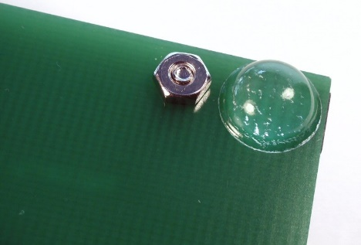
It is important to keep the board you've built up off the surface below it. The sharp ends of the wires could damage a table, for example, and contact with anything metallic could cause a short circuit.
Attach the 4 self-adhesive rubber feet to the bottom of the board, one at each corner.
Step 10 -- Prepare the Cable
This can be complicated, or you can contact Math Machines for a simple solution.
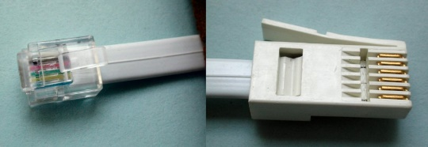
The CBL2 and LabPro use British Telecom (BT) plugs. Analog input probes (for CH 1, etc.) use BTA plugs with a right-hand release. BTA plugs are great for getting data into the interface, but they won’t work this switch. The Digital ports, require BTD plugs with a left-hand release. To connect this switch to your CBL2 or LabPro, you need a cable with a BTD plug on one end and a correctly oriented US 6-position, 6-connector (RJ12, 6P6C) plug on the other end.
You can buy a BTD plug and cable from Vernier as part number CB-BTD, which has bare wire at its other end. You can also buy a Digital Sensor Cable (MDC-BTD) and cut it in half to get two BDTs with bare wire ends. As of January 2022, either option costs $5 plus shipping. Also note that the cables are round, not flat, which can make the process of connecting an RJ12 plug more difficult.
Math Machines have a number of ready-to-use cables with the needed BTD on one end and RJ12 on the other end. Current cost is $4 each, including postage within the US.
Contact us at 10082 Dove Drive, Freeland, MI 48623 or email STEMmachines@gmail.com for more information.
Step 11 -- Assemble and Test the System
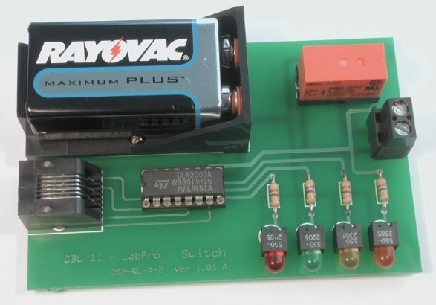
Insert a 9-Volt battery, making sure that it is oriented correctly.
Connect the digital output probe wire from the CBL2's DIG/SONIC port or the LabPro's DIG/SONIC port 1 to the phone jack, and connect the calculator to the LabPro.
Use the SIGNAL program to test your system.
Note: the circuit draws almost no current when it is not in use, so it can be left for several days with the battery in place. If you are storing the circuit for an extended period, however, you should always remove the battery.

Order | Component | # per board | Supplier | Part Number
A | Circuit Board | 1 | Math Machines | CS2-RL-A-2
B | Resistors, 470 ohm, 1/4 W | 4 | Mouser | 291-470
C | Socket, DIP 16 pin MIL Max | 2 | Mouser | 575-199316
D1 | LED, right angle, red | 1 | DigiKey | 350-1060-ND
D2 | LED, right angle, green | 1 | DigiKey | 350-1064-ND
D3 | LED, right angle, yellow | 1 | DigiKey | 350-1068-ND
D4 | LED, right angle, orange | 1 | DigiKey | 350-1050-ND
E | Terminal Block, 2-position | 1 | Mouser | 571-7969492
F | Phone jack, 6P6C, PCB mount, side entry | 1 | Mouser | 571-5551651
G | Battery cradle | 1 | DigiKey | BH9V-PC-ND
H1 | 2-56 Hex Machine Screw Nut | 3 | Barnhill | 231-256-A-01AAA
H2 | 2-56 x 1/4 Machine Screw | 3 | Barnhill | 402-256-14-0120A
I | Darlington Array, ULN2003A | 1 | Mouser | 511-ULN2003A
J | Relay, DPDT, 5V, DIP | 1 | Mouser | 551-MR82-5USR
K | Rubber feet | 4 | Mouser | 517-SJ-5306CL
L | Battery, 9-Volt | 1
M | BTD to 6P6C RJ12 cable | 1 | Math Machines | CABLE-BWTM30

For additional information about these parts or to inquire about kits or workshops, please email: STEMmachines@gmail.com

