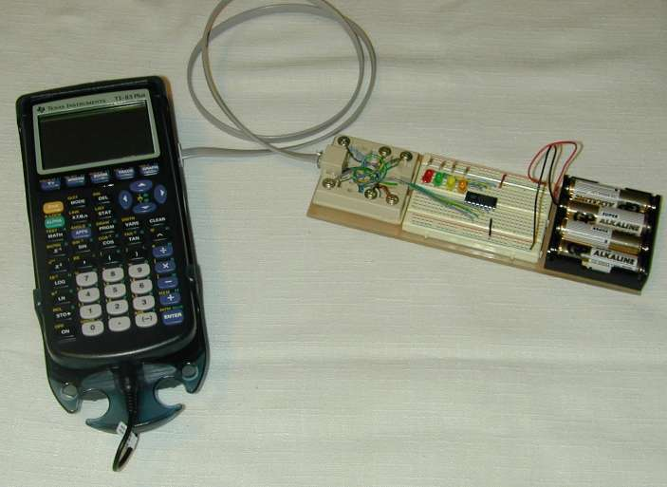
Breadboard Controller
This simple control circuit allows a TI graphing calculator to control the digital output lines of a CBL, CBL2 or LabPro, operating toy cars, lights, buzzers, motors and more. Construction of this controller does not involve soldering, making it extra safe for those just getting started with electronics. Even professionals commonly use breadboards for prototyping new designs, and this one is appropriate for anyone who wants the option of experimenting with their own ideas.
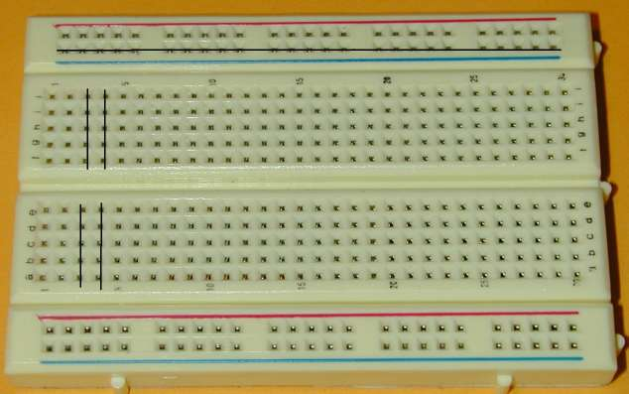
Step 1 -- Orientation to the Breadboard
Breadboards come in many sizes and configurations, but all have metal clips inside to provide a convenient method of connecting electronic circuits. In the board at right, each of the top 2 and bottom 2 horizontal rows is connected by a single metal strip as illustrated by the lines in the picture. A metal strip also connects each of the vertical columns of 5 holes in the main section of the board. Your board might be different. One way to verify the configuration is to remove the paper backing and look at the metal clips. Another option is to use an ohmmeter or multimeter to identify which holes are connected with essentially zero resistance.
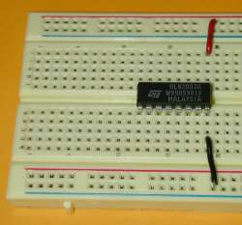
We’ll use the very top row as a connector for the positive supply voltage, Vcc, and the very bottom row for ground.
Step 2 – Insert the Integrated Circuit
The ULN2003A integrated circuit (IC) should be inserted as shown with the notch to the left. The integrated circuit pins are numbered counterclockwise from the lower left. Connect a black jumper wire from the IC's pin 8 to the ground row at the bottom of the breadboard. Also connect a red jumper wire from IC pin 9 to the top row, which will provide a positive voltage, Vcc, for the IC.
Step 3 -- Add the Resistors
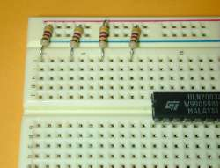
Be certain that you and all the people around you are wearing eye protection. Trim the leads of 4 470-ohm resistors so the resistors will fit neatly against the breadboard as shown. Insert them as shown from the top row, Vcc, to columns in the main part of the board. The first resistor goes in the first column and there are 2 empty columns between resistors. The resistors have colored bands of yellow, violet, and brown (for 47 x 101) and a gold band to indicate 5% tolerance.
Resistors conduct current in either direction, so the orientation doesn't matter; however, good practice calls for them to be oriented so the colors (yellow, violet, brown, and gold) go from the top down. That makes it easier for experienced users to quickly recognize the values.

Step 4 -- Add the LEDs
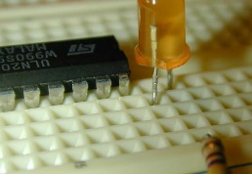
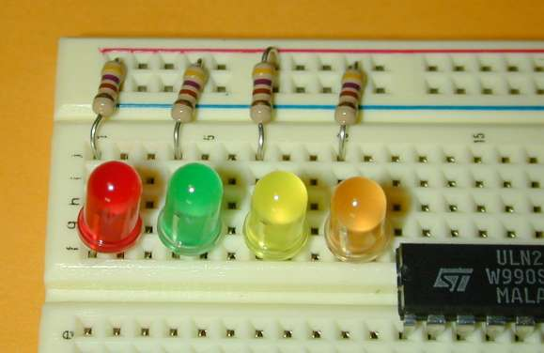
The positive pin for each LED must be in the same column as its resistor. That pin is normally longer than the other pin; however, both pins here need to be trimmed to equal lengths so the LED can fit against the breadboard. The LED's negative pin can be identified by either a notch or a flat side. The LEDs will fit best if the positive pin is at the bottom of its column and the negative pin is one column to the right and one row above the positive pin.
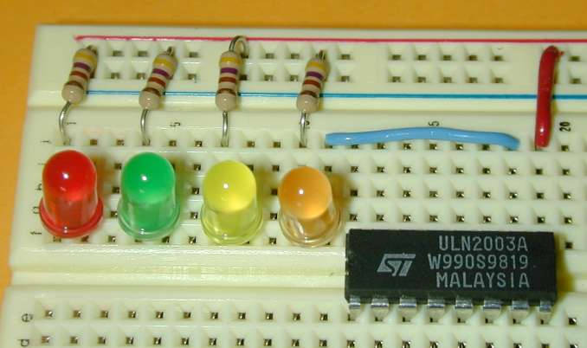
The order of the colors is not critical, but a sequence from left to right of red, green, yellow, orange gives a partial match with the color of wires from the LabPro or CBL2.
Step 5 – Connect the Right LED to the IC
Use a short blue wire to connect the negative of the right LED to IC pin 10 as shown. Connected this way, this LED will light if there is a high voltage from the LabPro at pin 7. Sending the value 1 (or 2⁰) from the calculator will activate this LED.
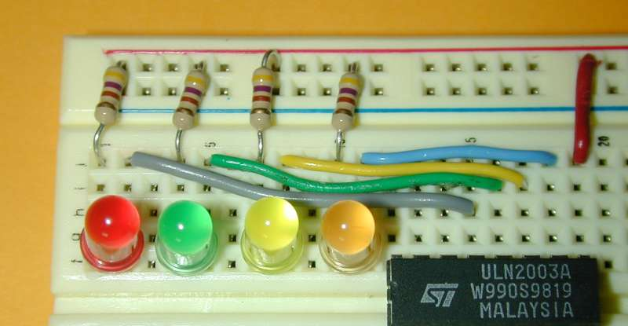
Step 6 – Connect the other LEDs
Use short wires to connect the other LEDs as shown. You can use other colors of wire, of course, but it's nice to maintain the color coding from the phone wire which will carry signals from the CBL2 or LabPro.
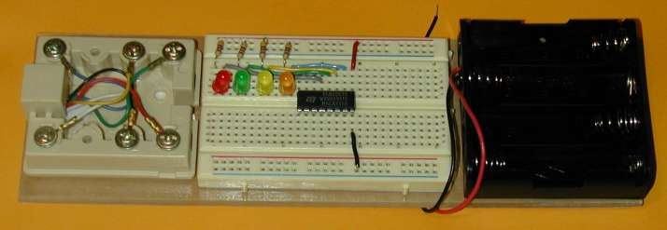
Step 7 – Mount the System on a Base
Prepare the wood or Lucite base and place the phone jack, breadboard and battery pack on the base to check their positioning. When you are satisfied with the positioning, use foam tape to fasten each in place.
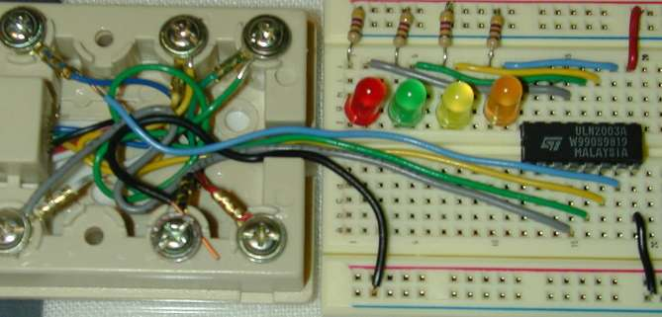
Step 8 – Connect the Breadboard to the Phone Jack
The information from the CBL, CBL2 or LabPro travels on 4 data lines, which are color-coded on the phone wire and on the jack. The instructions here and the illustration at right are for the LabPro or CBL2. To use an original CBL, skip to “Step 8 Alternate.”
Use a screwdriver to fasten one end of each color wire inside the phone jack, and insert the other end as shown. Match wire colors for the data lines to the jack colors. From right to left on the IC, the colors are:
  - blue to blue
  - yellow to yellow
  - green to green
  - white (or grey) to white
Connect the phone jack's black (ground) wire to the bottom row of the breadboard to provide a common voltage reference. The red wire from the LabPro or CBL2 is a low-capacity 5 V source and is not used in this circuit.
  - black to black

Step 8 Alternate (original CBL)
For the original CBL, you must use a special cable, called the "digital probe kit."
 | Left | ... | ... | Right
Phone jack | Blue | Yellow | Green | Red
Wire colors  on the board | White or Grey | Green | Yellow | Blue
Also connect: black to black
Step 9 – Prepare the Cable
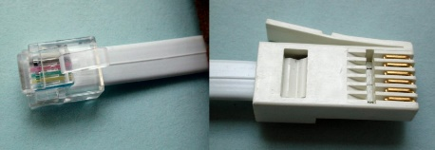
This can be complicated, or you can contact Math Machines for a simple solution.
The CBL2 and LabPro use British Telecom (BT) plugs. Analog input probes (for CH 1, etc.) use BTA plugs with a right-hand release. BTA plugs are great for getting data into the interface, but they won’t work for data output. The Digital ports, require BTD plugs with a left-hand release. To connect this switch to your CBL2 or LabPro, you need a cable with a BTD plug on one end and a correctly oriented US 6-position, 6-connector (RJ12, 6P6C) plug on the other end. The original CBL requires still a different BT connector.
You can buy a BTD plug and cable from Vernier as part number CB-BTD, which has bare wire at its other end. You can also buy a Digital Sensor Cable (MDC-BTD) and cut it in half to get two BDTs with bare wire ends. As of January 2022, either option costs $5 plus shipping. Also note that the cables are round, not flat, which can make the process of connecting an RJ12 plug more difficult.
Math Machines have a number of ready-to-use cables for either the original CBL or the CBL2/LabPro. Current cost is $4 each, including postage within the US.
Contact us at 10082 Dove Drive, Freeland, MI 48623 or email STEMmachines@gmail.com for more information.
Step 10 – Assemble and Test the System
- Connect the leads from the battery pack, with positive (red) to the top row of the breadboard and the ground (black) to the bottom row. Insert the batteries.
- Connect the digital output probe wire from the CBL's Dig Out, the CBL2's DIG/SONIC port or the LabPro's DIG/SONIC port 1 to the phone jack, and
- Connect the calculator to the LabPro with the cable as prepared in step 9.
Use the SIGNAL program to test your system.
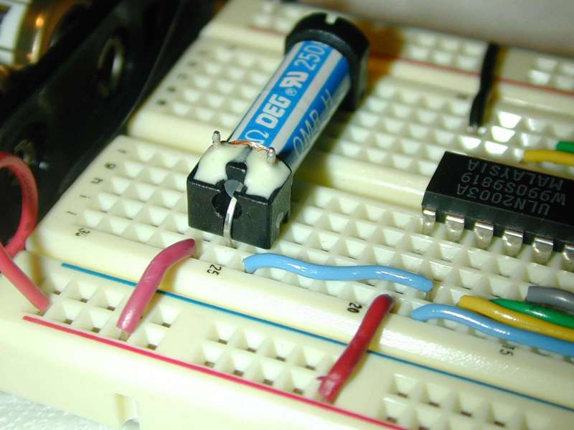
Step 11 – Add a Relay
Disconnect the battery pack leads and insert the SPST relay as shown, with its 3 pins towards the top of the breadboard. Connect one jumper from the board positive row to one side of the relay's electromagnetic coil, and connect the other side of the coil to pin 10 of the IC.

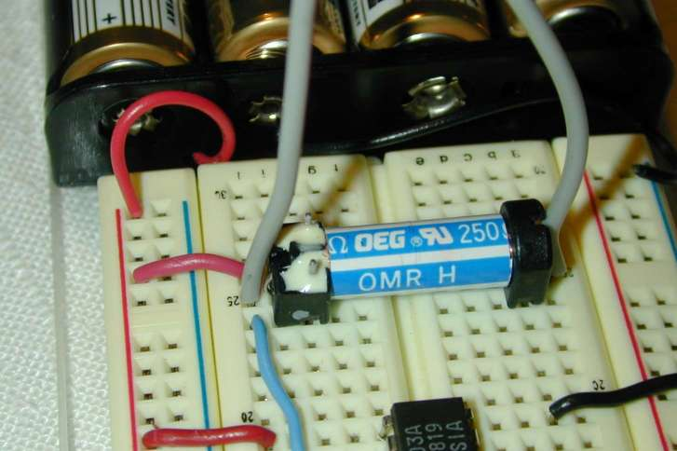
Step 12 – Use the Relay to Turn Something On and Off
This relay is the most basic type of switch--a "single-pole, single-throw," or "SPST" switch. That means it simply conducts one line of electricity when activated (or "closed") and it doesn't conduct when it is "open" or not activated. The photo at right shows wires from a battery-powered car connected to the two ends of the relay, so the car’s motor will be active if and only if the relay is activated. If you have room on the breadboard, the system can control up to 4 relays and 4 different devices such as a car, a fan, a buzzer and more. Note that this system only serves as a switch. The external device must have its own power source.
Only use low-voltage, low-current DC devices. Never attempt to control AC devices.

Suggested Component List (part numbers may be out-of-date)
Description | Quantity | Source | ID #
Battery holder, 4 AA | 1 | Mouser | 12BH348
Batteries, AA | 4 | Local
Breadboard, 400 pt | 1 | Jameco | 20600
Buzzer, mini | 1 | Jameco | 24871
LED Green | 1 | Jameco | 34761
LED Orange | 1 | Jameco | 107393
LED Red | 1 | Jameco | 94511
LED Yellow | 1 | Jameco | 34825
Lucite or wood | 1 | Local
Modular connector, 6 cond, RJ 12 | 1 | Jameco | 79273
Foam Mounting tape |  | Local
Pin-strip Headers, 5 pins | 1 | Mouser | 517-834-02-36
Relay, SPST, 5 V, 250 ohm | 1 | Mouser | 431-1405
Resistors, 470 ohm, 1/4 W | 4 | Mouser | 291-470
Rubber Feet | 6 | Mouser | 517-SJ-5003GY
Surface mount phone jack, 6 cond. | 1 | Jameco | 71984
ULN2003A DIP-16 NPN Dar array | 1 | Jameco | 34278
Wire, 22 AWG, solid, asst. colors |  | Jameco | 122xxx

For additional information about these parts or to inquire about kits or workshops, please email: STEMmachines@gmail.com
Revised 14-January-2022

